

INDUSTRIAL TRAINING REPORT
at
CREST BUSINESS SOLUTIONS SDN BHD

ABDUL HAKIM BIN ABDUL RAHMAN
2019437622

UNIVERSITI TEKNOLOGI MARA

INDUSTRIAL TRAINING REPORT

at

B-3-01(b), CoPlace 1 Cyberjaya,
2270 Jalan Usahawan 2, Cyber 6,
63000 Cyberjaya, Selangor
13th September 2021 until 25th February 2022

ABDUL HAKIM BIN ABDUL RAHMAN
2019437622

Report submitted in partial fulfillment of the requirement for the Diploma in Computer Science

Faculty of Computer and Mathematical Sciences

FEBRUARY 2022
APPROVED BY:

Name | : | Irdina Syahira Binti Mohamad Sanny
Department | : | Information Technology (IT)
Signature |   :
Date | : | 12/1/2022

ACKNOWLEDGEMENT

Alhamdulillah, praise be upon to Allah for giving me strength and time to complete this project.

First and foremost, I would like to express my gratitude to my supervisor, Ms Irdina Syahira Binti Mohamad Sanny for her assistance, cooperation, and guidance during my internship in this company. A very special appreciation goes to my Academic Supervisor, Ts Dr Hamidah Binti Jantan for making her time to guide and advice me during my internship at Crest Business Solutions Sdn Bhd. I really appreciate the time she took out of her busy schedule to guide me and other interns. Special gratitudes to my parents, Abdul Rahman bin M. Jais and Alawiyah binti Dollah for the encouragements, emotional help and supports during my internship. Not to forget all of the knowledge, supportive words and commitments that they gave for making me successful in accomplishing my goals during this industrial training.
Thank you to my friends for sharing the knowledge and also the supportive words in making us all together successfully in finishing this internship. Lastly, I would like to give appreciation to the company staffs for the knowledge, guides, cooperation and memories from the first day until the last day of my internship period.
Last but not least, thank you very much and may ALLAH SWT bless all of them.
TABLE OF CONTENT

ACKNOWLEDGEMENT
LIST OF FIGURES
1.0 INTRODUCTION
  - Industrial Training Program Background
  - Industrial Training Objectives
  - Introduction of the Project
  - Objective of the Project
- ORGANIZATION BACKGROUND
  - Introduction
  - Organization Profile
  - Organization Vision and Mission
    - Organization Vision
    - Organization Mission
  - Organization Logo and Address
  - Organizational Structure and Hierarchy
  - Organization Location
- TASK REPORT
  - Document Management System (EDMS)
    - Introduction
    - Microsoft SharePoint
    - System Interface
    - Document Control and Filling Management (Migration)
  - iDoc Approval
    - Introduction

1.0 INTRODUCTION

1.1 Industrial Training Program Background

Industrial Training is a mandatory course for all Diploma students of Computer Science (CS110) that need to be taken after they had finished and passed the compulsory courses. The meaning of industrial training refers to the placement of students at a host organization, for them to gain experience and knowledge in the real work environment. Only after they had finished and passed their industrial attachment, the students will be able to receive their certification of diploma.
This industrial attachment requires 24 weeks of internship at their host organization and the scope must connect with their respective field of study. This is important as they need to apply what they had learned at their university to the workplace.
However, according to the placement of the industrial internship, it can be different than what was learned at the university. During the industrial internship, students get more insight on how the real workplace environment is and how to work with different types of people. It is more challenging as they have to think more maturely and figure out the solutions to the problems occurred with minimal supervision. It also tests students to become more independent.
1.2 Industrial Training Objectives

The general objective of industrial training program is to:

- Expose students to the real and working environment.
- Practise the theories learned at universities in making and solving real-world issues related to their respective areas of expertise.
- Provide exposure to the latest technology knowledge and development applied in the industry.
- To strengthen the bond of collaboration between university and industry.

The specific objective of industrial training is to give students the opportunity to:

- Understand and instil a responsible attitude in the actual working life.
- Get industry experience that corresponds to their respective area of expertise.
- Appreciate the value of professional ethics.
- Improve soft skills that fit in the work environment and improve communication skills.
- Assess the student’s career, knowledge and self-esteem.
- Enhance student’s marketability to be more competitive.
- Sow, nurture and further develop entrepreneurial characteristics through exposure to reality and career opportunities.
- Establish professional relationships within the industry.
- Apply and train the ability to write good reports.

1.3 Introduction of
2.0 ORGANIZATION BACKGROUND

2.1 Introduction
Crest Business Solution Sdn Bhd is an IT Solutions and Services company based in Malaysia with support centers in India and Philippines. Crest Business Solutions specialize in developing software products and providing services to cater to the automation and process improvement needs. Within a short span of time, Crest Business Solutions have sharpened the skills in the relevant domain. Leveraging on our extensive knowledge and experience in delivering business solutions for customers across a wide gamut of industry domains including BFSI, Energy, Hi-Tech, Oil & Gas, Telecom, Property, Real Estate, Education, Retail, and e-commerce.
2.2 Organization Profile
Crest Business Solutions is MSC Status company based in Malaysia. We cater to the information technology and outsourcing needs to a wide gamut of industries. Crest Business Solutions offers a wide range of solutions to their customers They emphasize their solutions based on client business goals and objectives. The company offer full cycle custom software development and integration services, from product idea, design & development to outsourcing support and enhancement.
Crest Business Solutions has the reach and resources to provide high caliber information technology talent from India and Philippines on Contract, Contract to Permanent and Executive Placements.
Most of the Malaysia’s mid-to-large organizations seek foreign talent to fill up their IT recruitment needs. Here we assist companies across full cycle of recruitment services (from sourcing to on boarding) till managing the candidate’s payroll, work permits, etc.
We can effectively handle the recruiting process and all associated costs, thereby allowing you to focus on your core business. IT staff augmentation services work well for companies who must scale up and down depending upon project requirements, or those looking to strengthen up their core team with top notch IT professionals
Depending on business needs we assist companies in temporary and contract application developers, engineers, help desk, technical support, web developers, database experts, networking, analysts etc.
2.3 Organization Vision and Mission

2.3.1 Organization Vision
Our aim is to deliver sustainable benefits to customers have continuous growth of the company achieve welfare of employees, their families and society
2.3.2 Organization Mission
Striving to provide value driven services to the automation needs of our customers using best in class tools and technologies.

2.4 Organization Logo and Address


Figure 2.1: Crest Business Solutions Sdn. Bhd. Logo

Business Address : B-3-01(b),CoPlace 1 Cyberjaya,
2270 Jalan Usahawan 2, Cyber 6,
63000 Cyberjaya, Selangor, Malaysia
Phone : +60386861707
Email : info@crestsolution.com.my
Official Website : https://www.crestsolution.com.my
2.5 Organizational Structure and Hierarchy
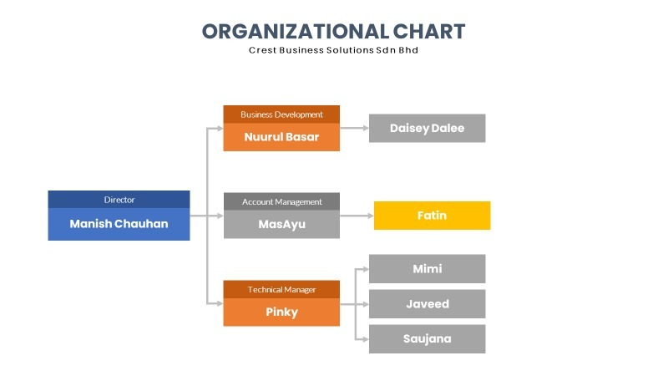
Figure 2.2: Organizational Structure of Crest Business Solutions Sdn Bhd

2.6 Organization Location
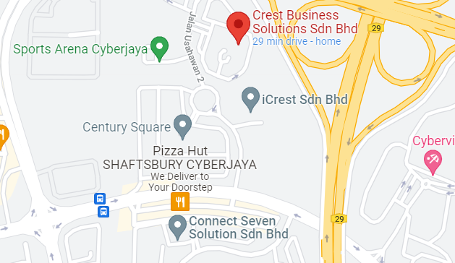
Figure 2.3: Location of Crest Business Solutions Sdn. Bhd.
3.0 TASK REPORT
This chapter explains on the work and assignments that have been done during the industrial training period. The work done that will be covered in this chapter are Document Management System (EDMS) and iDoc Approval.

3.1 DOCUMENT MANAGEMENT SYSTEM (EDMS)
3.1.2 INTRODUCTION
Document Management System or EDMS is a project held for a company named UMW Holdings to implement the document management, document control and filing to replace from the UMW current system which is called Laserfiche into SharePoint DMS (Microsoft 365). The process flow for Laserfiche are much longer that the company decided to change the medium to Microsoft SharePoint that have shorter flow to file the documents. The task that I was given throughout this internship were to assist the workers such as demo system design, assignation of client’s workers role by department into the system and document control and filing management (migration).
3.1.3 MICROSOFT SHAREPOINT

Figure 3.1: Microsoft SharePoint Logo

SharePoint is a platform to support collaboration and content management system. It is a central web-based portal. Using SharePoint, you can manage your colleague’s and your own documents, social activities, data, and information. It allows groups to set up a centralized, password-protected space for document sharing. Documents can be stored, downloaded, and edited, then uploaded for continued sharing. SharePoint offers such a wide array of features that it is very challenging for any one person to be an expert across all the workloads.
Using Microsoft SharePoint, I was given a task to explore as well as helping on creating the demo site of the management system page as an example to show to the client.
3.1.4 SYSTEM INTERFACE

Figure 3.2: Document Submission Platform

Figure 3.3: Document Control Management Interface

The system consists of five sections in which five of them are in the main screen of the system as shown in Figure 3.2. The sections are New Document Submission, Document Tracking, Document Library and My Tracks. For the document management system interface, user need to click on the ‘New Document Submission’ section as shown in Figure 3.3.
Figure 3.4: New/Re-submission Dropdown List

Figure 3.5: Category Dropdown List

Figure 3.4 shows the options list for the first field which is ‘New/Re-submission’. Requestor can choose either to resubmit or send new documents. Category field is also needed to distribute and differentiate the documents into their type. The requestor can choose any of the category of the documents desired as shown in Figure 3.5 to be submitted in the system.
Figure 3.6: Type of Document Dropdown List

The requestor can choose the ‘Type of Document’ to be submitted as shown in Figure 3.6.This field must be filled so that the document can be organized in the SharePoint Folder.The requestor then can save the document details after completing all field.
Figure 3.7: Attach Documents Pop-up Window

The attach files pop-up window will appear after save the documents as shown in Figure 1.7. Any files with different formats can be attached in here and the requestor also can choose each of the versions of the files if required. The files attached also can download and preview for the user’s reference.‘Submit Request’button is to submit the documents and ‘Go Back’ or ‘Close’ button can be used to close the pop-up window.
Figure 3.7: Attach Documents Pop-up Window

After submitting the request, the workflow will successfully start and to check the status, the requestor can click on ‘Request Status’.

